AWS RDS LAB 3

RDS backup and restore - step by step guide for MySQL database.

Step1 : Login to AWS account and navigate to RDS console.

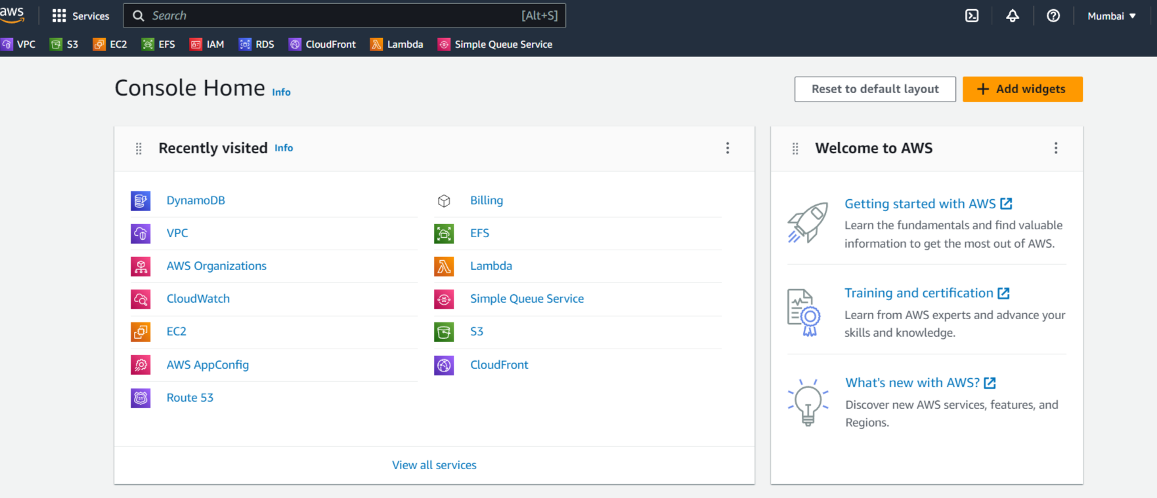

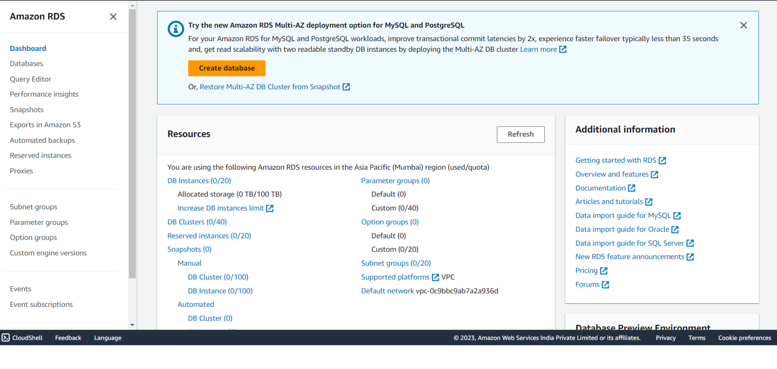

Step 2: Go to the database section and select the database which you want to take restore and backup.

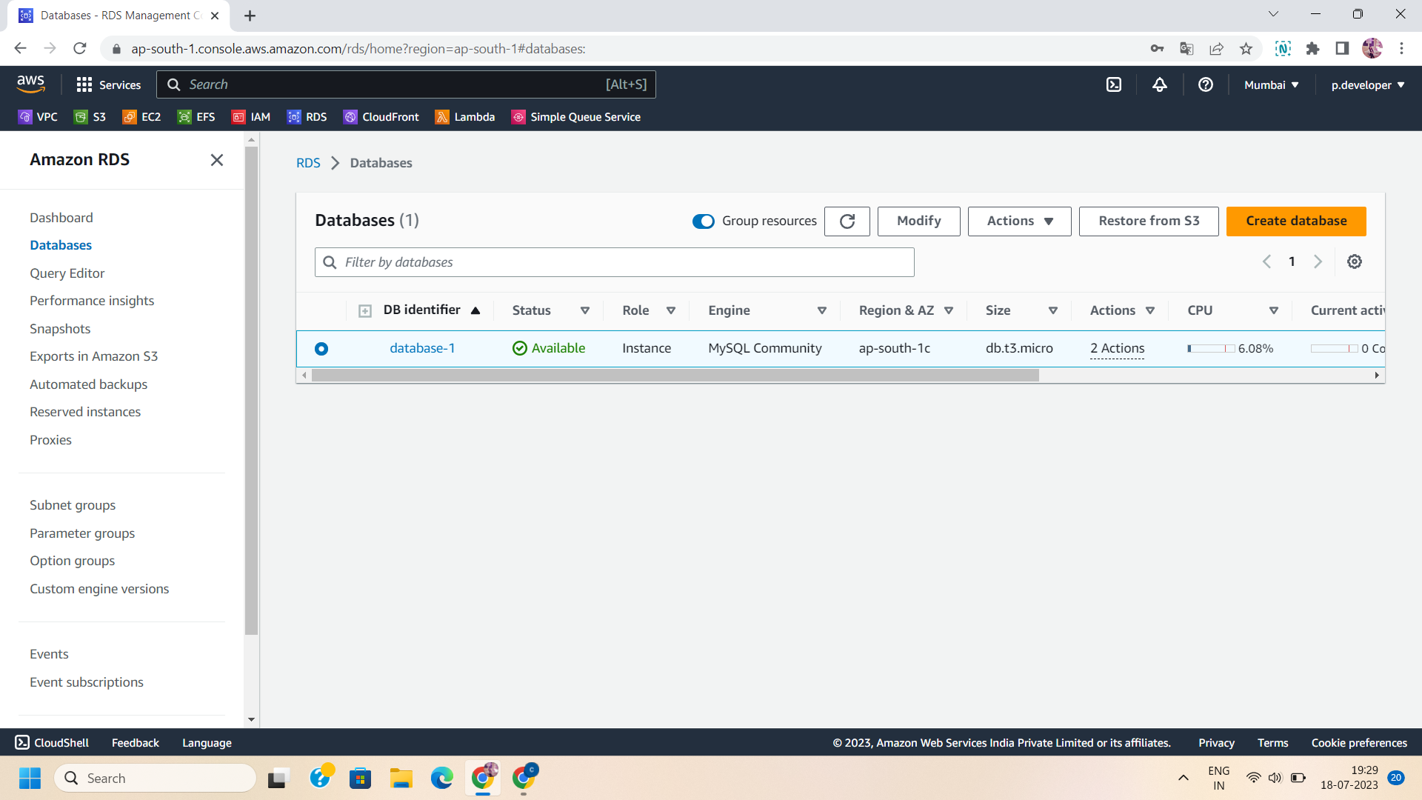

Step 3:Select the MySQL database and click on actions.Choose the “take snapshot” to take a snapshot of the database.

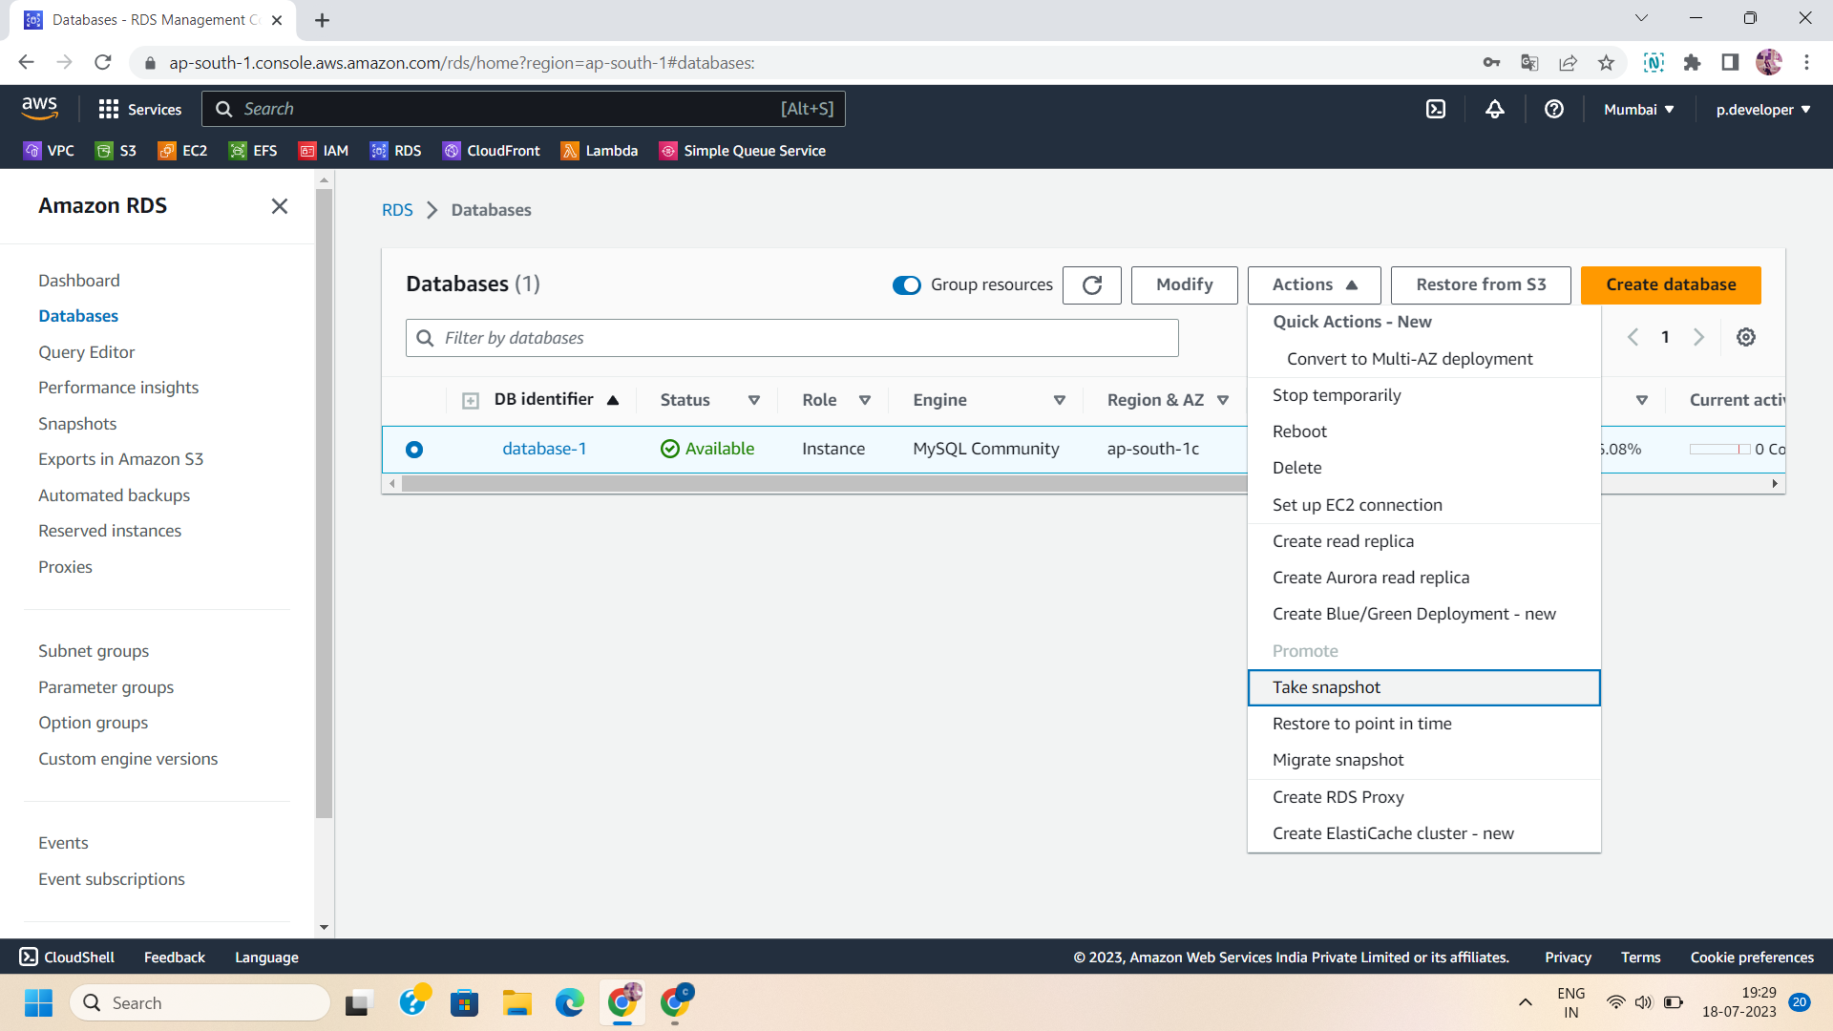

Step 4 : To take a snapshot ,select the database instance and give a unique name to your snapshot.

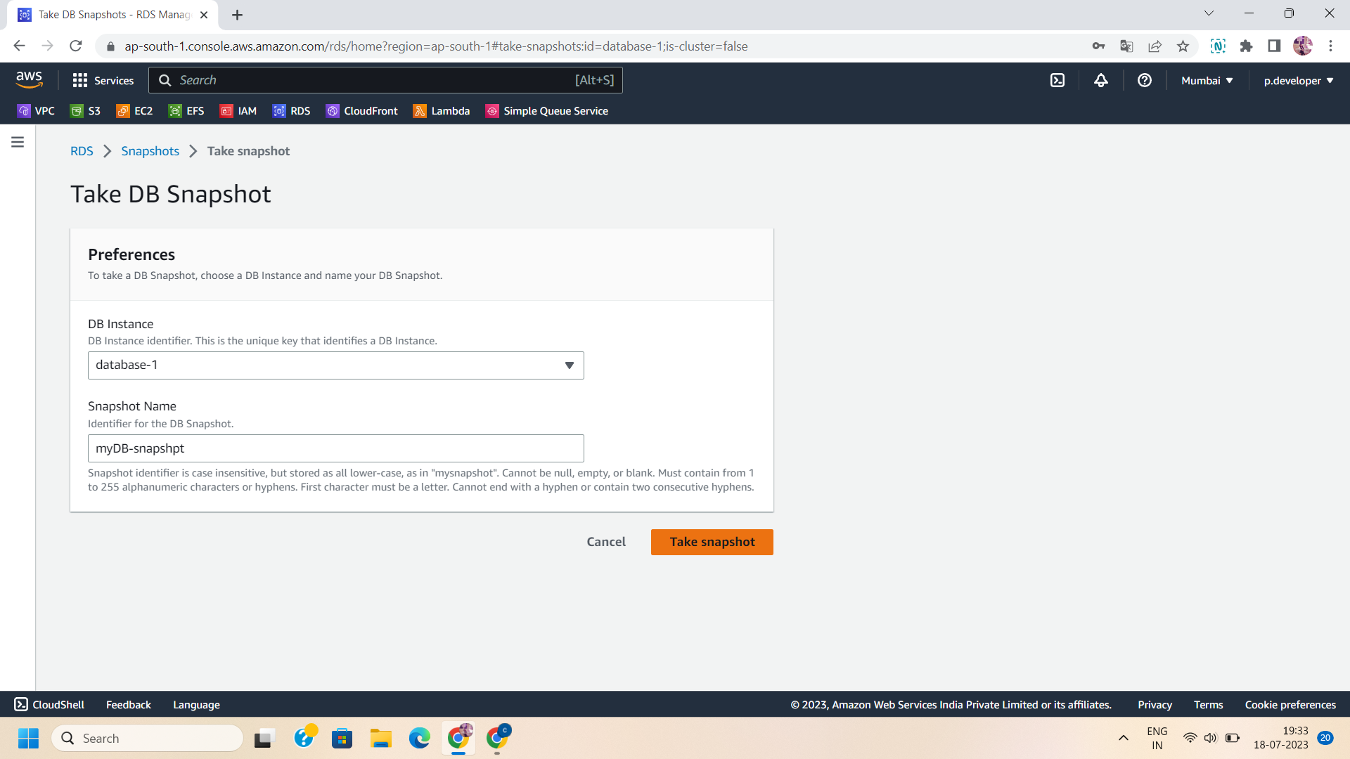

Step 5: Navigate to the “system” console in the snapshots.

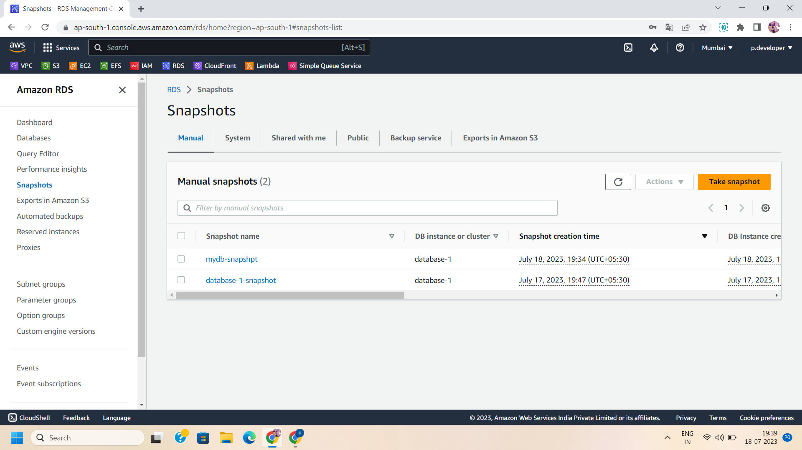

Step 6: In the system console ,select the database snapshot that you want to restore.

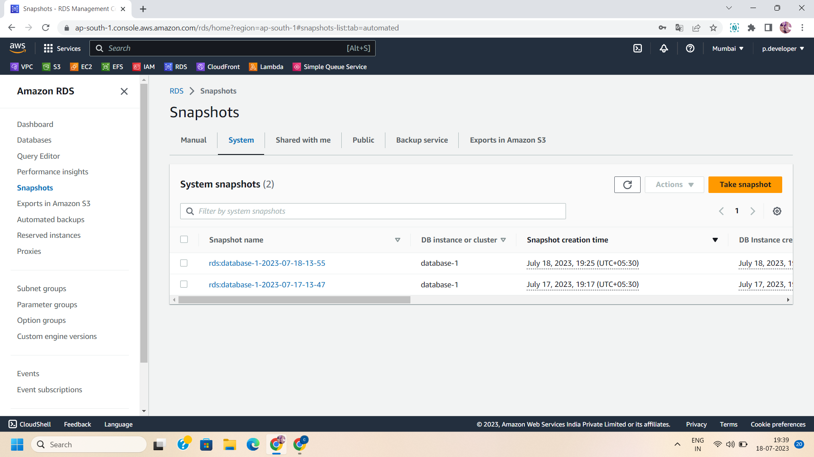

Step 7: Click on the “Action” button and select “restore snapshot” to restore the database.

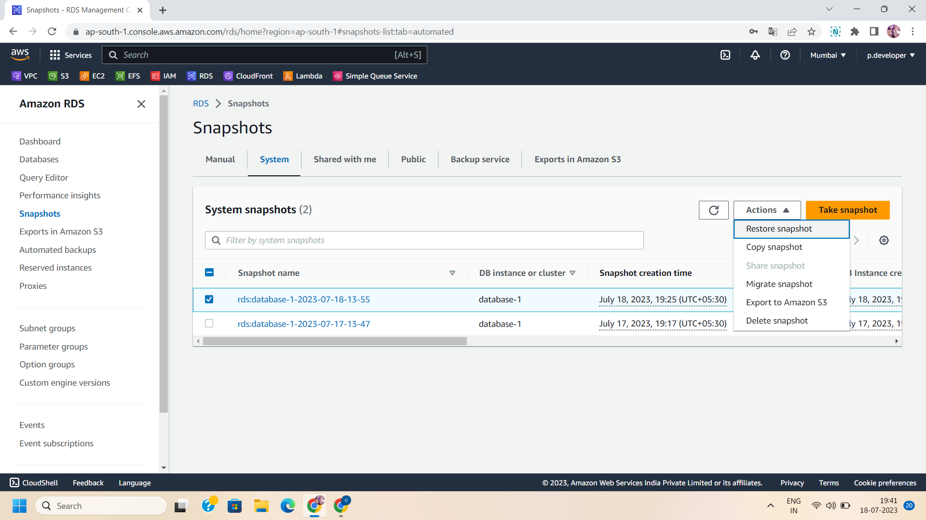

Step 8: Configure the DB instance settings,their availability and durability for restored database.

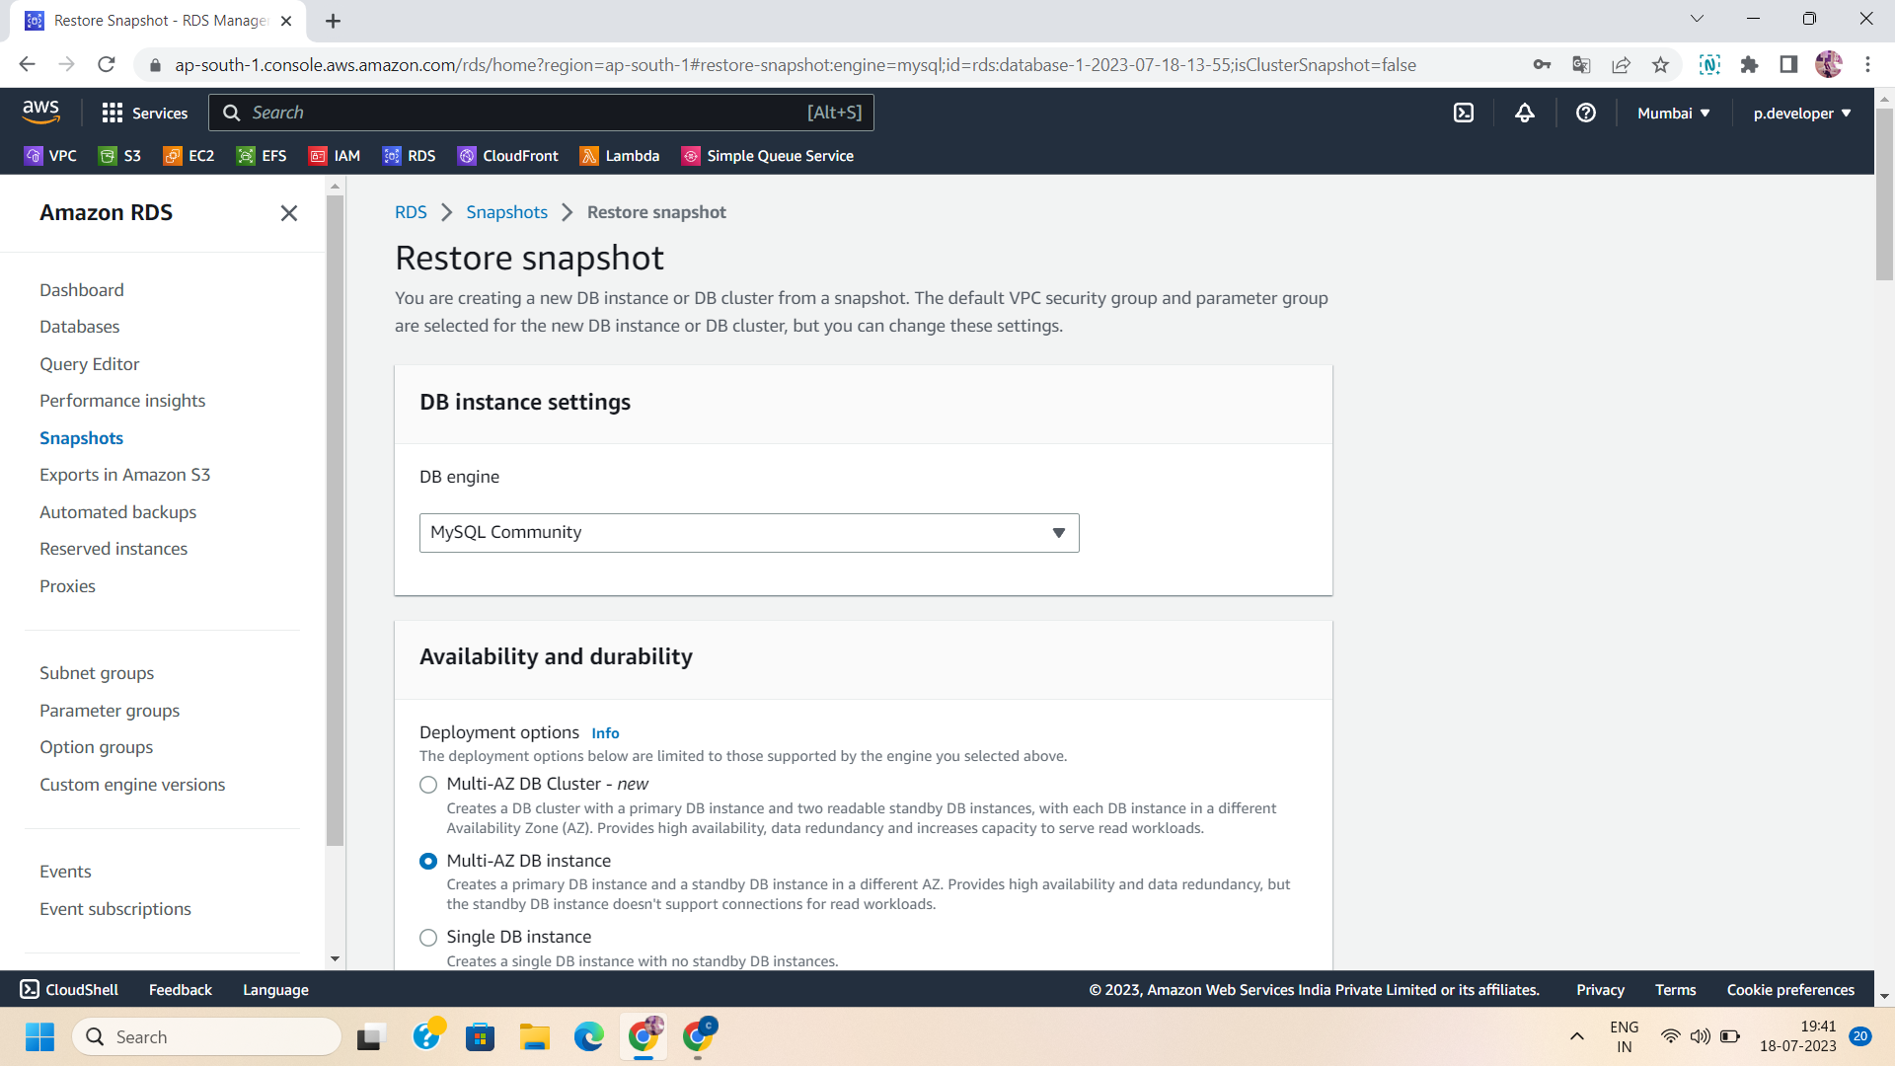

Step 9: Manage Instance configurations: Name the restored database and select the DB instance class.

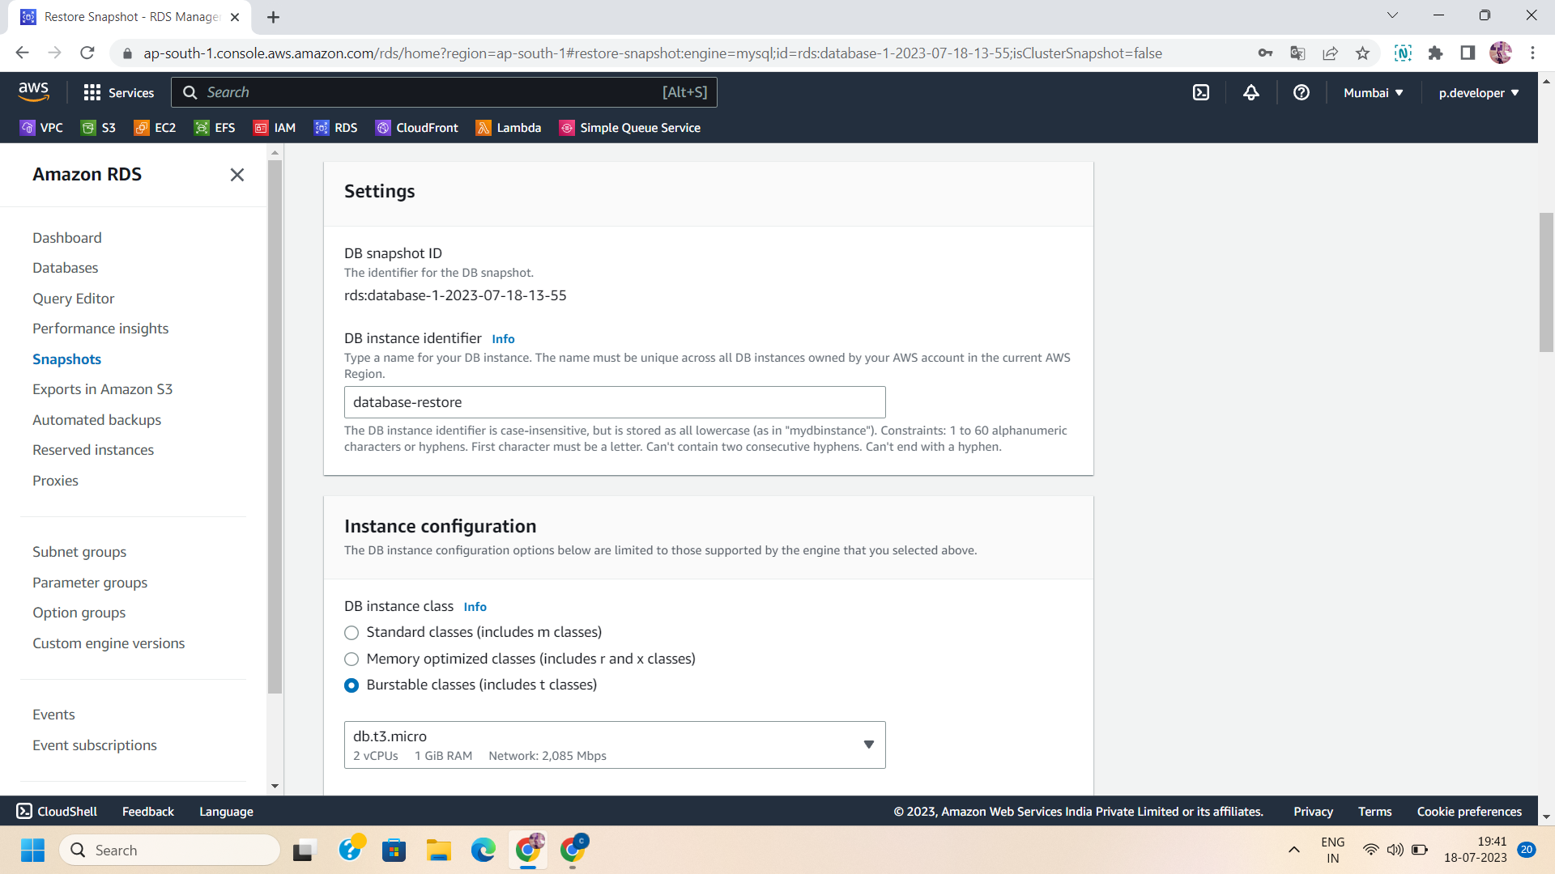

Step 10: Configure the storage settings:

Select the storage type and allocated storage for your restored database.

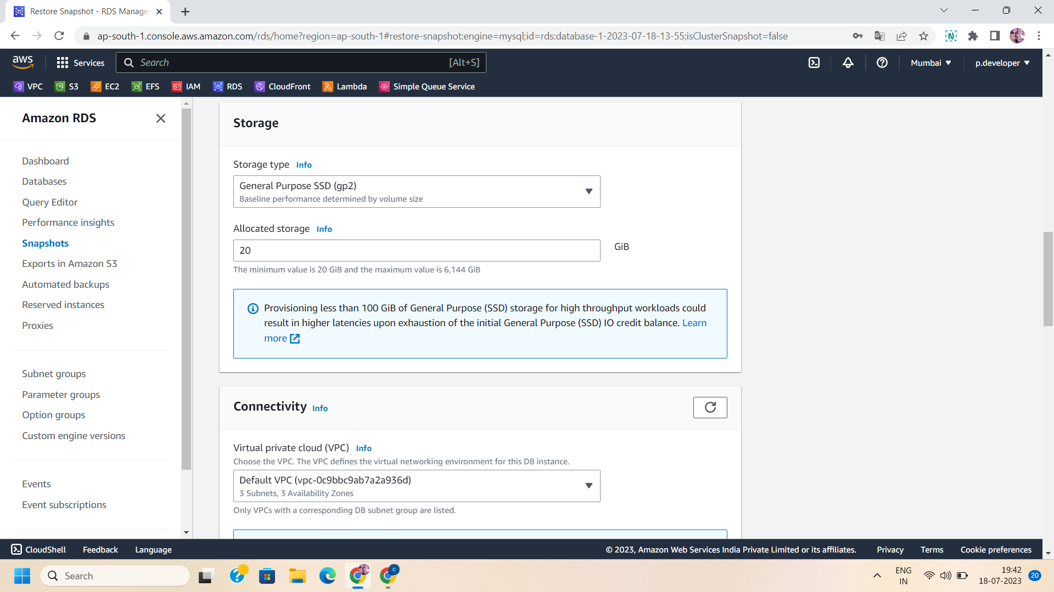

Step 11: Manage the Connectivity settings:

Select the VPC ,their subnet groups and public level access for your restored database.

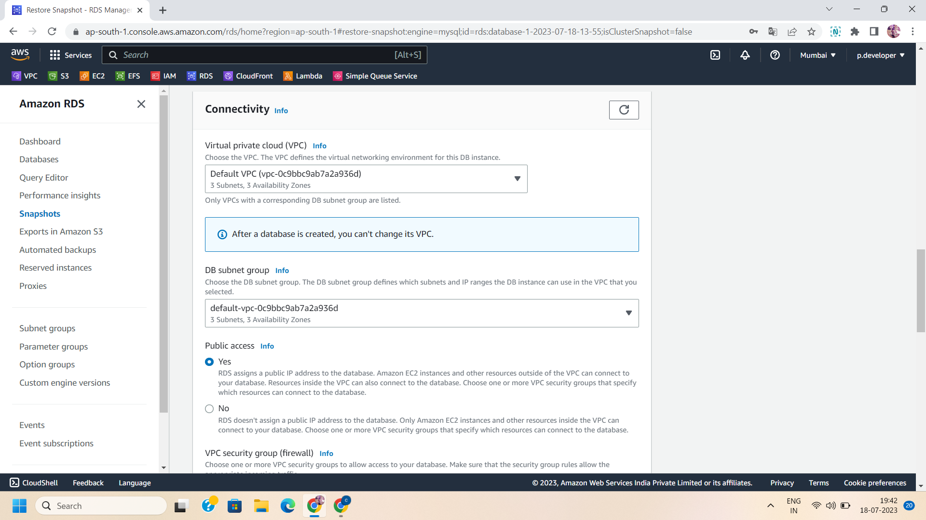

Step 12: Enable or disable the encryption as per your requirements and click on “Restore DB instance” to restore the database.

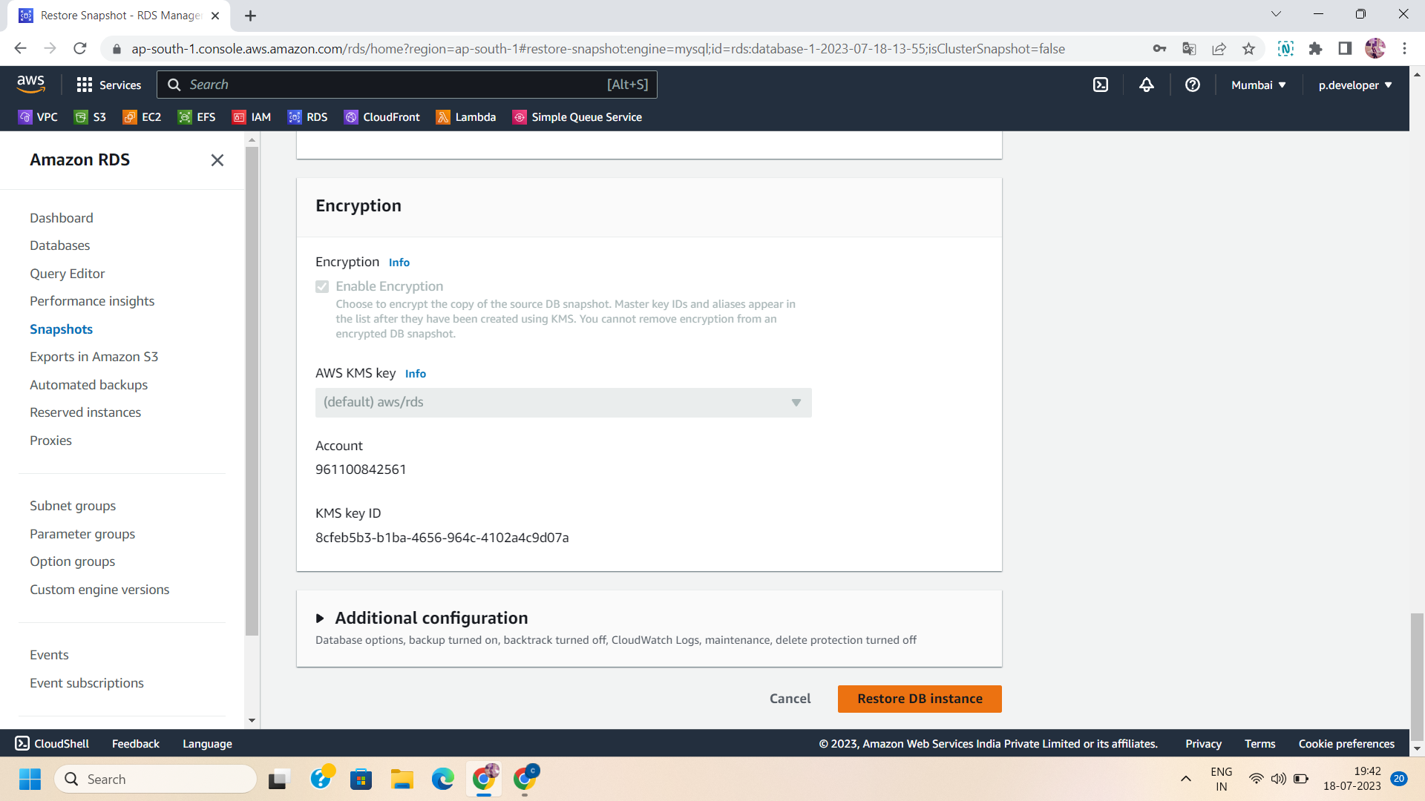

Step 13: On click on restore database,your restored database will be available in your specified region.

